**​​Overview/Description:**  
This report/tool will allow a user to input a list of HICs or SSNs and receive a real time list of phone numbers for each of the HICs/SSNs.   
  
**Usage Directions:**

1. The tool needs an input file in order to work.
   * Must be .xlsx
   * Must have values in first column of first sheet
   * Must contain either HICs or SSNs
2. The tool has to be run from the VDI
3. Can be run with double click on the script file
   * ​User needs to change the program that uses a .py file using the [directions](https://my.admedcorp.com/departments/DataAnalysis/DACollaboration/DAwiki/Pages/Changing%20Python%20Programs%20to%20run%20on%20double-click.aspx) at the end of this document
4. The program will require user input
   * the type of numbers HIC/SSN
   * location of .xlsx file
5. Manual solving of a captcha
   * because the program scrapes phone numbers from a website that requires a captcha to be solved occasionally, the user is responsible for going to this webpage and solving the captcha when instructed

**Tool Diagram:**

​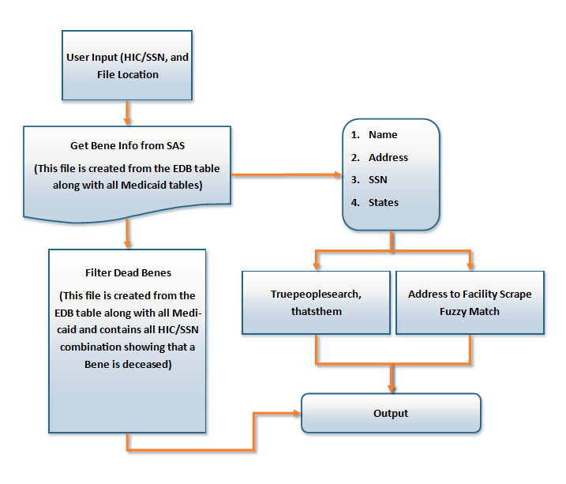

​​​**Current Sources:**

1. Below is a list of sources that the tool currently searches for telephone number
   * ​The EDB sas bene file,
   * All 8 Medicaid state bene files, (AL, AR, GA, LA, MS, NC, TN, WV)
   * Web scrapes
     + Truepeoplesearch.com
     + thatsthem.com
   * Fuzzy matches facility scraped phone numbers from AL, GA, LA, WV

**Locations:**

1. ​Actual python program that can be opened in the VDI to run CATS report/tool
   * ​​location is S:\DA_work_files\Python\Progr​ams\Bene Phone Lookup Tool (CATS

**Changing python to run on double click.**

* This write up will show how a user can set up python programs to allow user to run python backed programs without having to open Spyder or python. When properly set up, a user can just double click on a python program script and have the program run.

**Steps:**

* In the VDI, go to a .py program file. Use the 'Sober Living.py' file found here >**S:\DA_work_files\Python\Programs\Change to double click.py**
* right click on the PY File
* left click on 'Properties'
* left click on the 'Change...' button
* left click on the 'Browse' button
* type, paste, or navigate to "C:\Program Files\Anaconda3"
* double click on the Application file named 'python'
* double click 'OK'
* double click 'Apply'
* double click 'OK'

**What to expect:**

* After performing the above process, you will be able to double click on a .py program script and run it automatically. This will only work for programs that are complete and set up to be used this way, such as the Sober Living.py script.